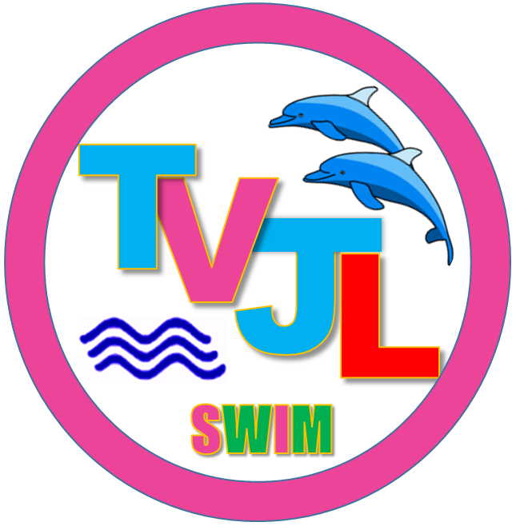
Thames Valley Junior League

Admission by programme

£5.00 per person

Children 12 & under and OAPs (60+) free

Raffle £1 a strip

